TASK # 1: Introduction to Internet of Things (IOT)
- Definition of IOT:
The Internet of Things (IoT) is a network of physical devices equipped with sensors, software, and connectivity that enables them to collect and exchange data over the internet.
- IOT Architecture:
Sensor -> ESP32(Microcontroller) -> Cloud -> User
In my Project:
DHT22 -> ESP32 -> Serial Monitor
- Data Flow:
- DHT22 measures temperature and humidity.
- ESP32 reads the sensor data.
- ESP32 processes the data.
- Data is displayed on the Serial Monitor.
- User monitors environmental conditions.

- Real-World Application:
- Smartphones.
- Weather monitoring stations.
- Greenhouses.
- Industrial monitoring.

TASK 2: Sensor Data Simulation
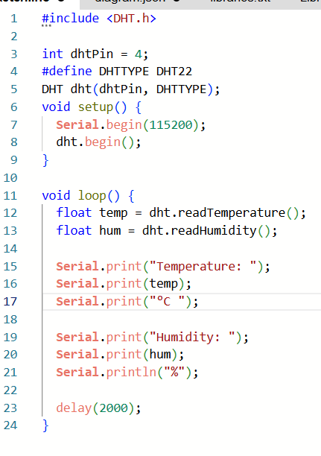
Arduino Code:

Circuit Diagram:
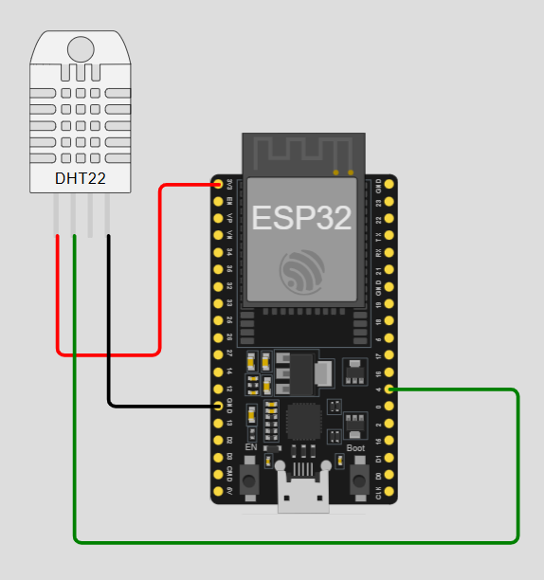

Serial Monitor:
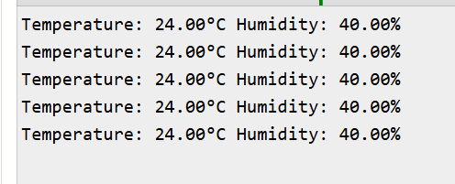

TABLE:
Reading No. | Time (sec) | Temperature (°C) | Humidity (%)
1 | 0 | 24.0 | 40.0
2 | 2 | 24.0 | 40.0
3 | 4 | 24.0 | 40.0
4 | 6 | 24.0 | 40.0
5 | 8 | 24.0 | 40.0

TASK # 05:
Smart Environmental Monitoring System Using ESP32 and DHT22:
- Objective:
The objective of this project is to monitor environmental conditions by measuring temperature and humidity using a DHT22 sensor connected to an ESP32 microcontroller.

- Component Used:
Component | Quantity
ESP32 | 1
DHT22 | 1
Jumper wires | 3
- Circuit Diagram:


- Pin Connections:
DHT22 Pin | ESP32 Pin
VCC | 3V3
SDA | ESP4
GND | GND1

- Working Principle:
- The DHT22 sensor measures temperature and humidity.
- ESP32 reads the sensor values every 2 seconds.
- The data is processed by the microcontroller.
- The readings are displayed on the Serial Monitor.
- The user monitors environmental conditions.

- Source Code:


- Result:
- Serial Monitor:


- TABLE:
Reading NO. | Time (sec) | Temperature (°C) | Humidity (%)
1 | 0 | 24.0 | 40.0
2 | 2 | 24.0 | 40.0
3 | 4 | 24.0 | 40.0
4 | 6 | 24.0 | 40.0
5 | 8 | 24.0 | 40.0

- Applications:
- Smartphones.
- Weather monitoring stations.
- Greenhouses.
- Industrial monitoring.

- Conclusion:
The Smart Environmental Monitoring System successfully measured temperature and humidity using the DHT22 sensor and ESP32 microcontroller. The collected data was displayed on the Serial Monitor at regular intervals. With this small project we were able to put IoT monitoring into practice and it can be continued in the future for cloud monitoring.

